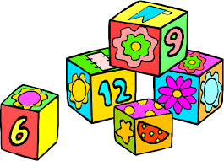
Maths tips 2-3 years
There are lots of fun ways to encourage your child to practice and develop their mathematical skills at home:
Doing the washing: Children love to help so why not give them a little task
- Matching socks and putting them into pairs
- Sorting socks into different colours and patterns
- Sorting washing into different e.g. big and little tops, trousers etc
Singing Number rhymes
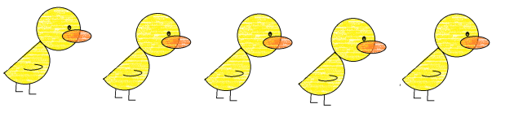
- At nursery we always sing a range of different number songs including five little ducks, encourage and act out the song using your fingers or actual objects e.g. ducks that your child can see and touch.
Number stories
- Here are just a few ideas of popular number stories: Three little pigs, Three Billy Goats Gruff, Hungry Caterpillar, Goldilocks and the three bears.
Water and sand play
Learning mathematical skills and concepts needs to be as fun as possible, try these ideas in the bath or even a plastic dish from your dishes:
- Provide a range of empty water bottles or containers for your child to fill and empty
- Talk about the size of the bottles, big, little
- Introduce different concepts e.g. full, empty
- Draw shapes in the sand with different tools e.g. brushes, straws, sticks
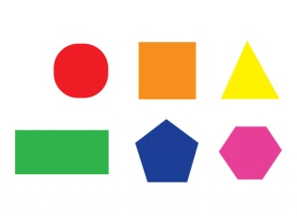
Practice mathematical skills in everyday routines:
- Counting steps as you go up stairs
- Counting buttons as they get ready
- Arrange shoes in order of size
- Help sort and count fruit and vegetable
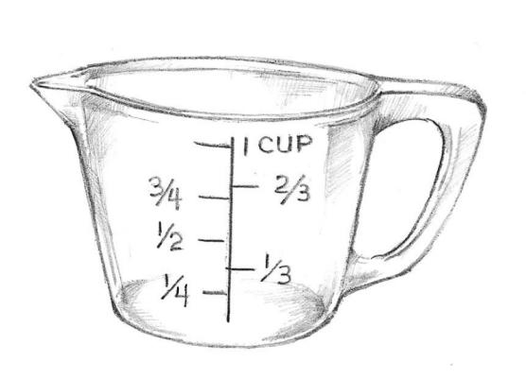
Food
- Can you help set the table for two people? Can you get me two plates?
- Can you cut your toast into 4 pieces? Can you cut it into triangles?
- Help measure and count ingredients e.g. two spoons of water, three eggs
Mathematics at nursery
We always try and make mathematics as fun as possible at nursery by providing a range of different and interesting objects, children can then count, arrange, sort and categorise e.g. pine cones, twigs, pompoms, leaves, small world animals, baskets, boxes. We also use everyday objects including: calculators, scales, tape measures, measuring jugs and magnifying glasses.
Please share your photos and child’s learning on Tapestry

